Augmented Reality

* Augmented Reality – A technology that superimposes Computer generated images on the users view of the real world thus providing a composite view
* Tools: Phones, Microsoft Hololens, Meta2
  + Requirements: camera, compass, G.P.S, accelerometer, CPU, GPU, RAM
* 4 types of AR:
  + Markerbased AR / Image Recognition AR
    - Use an object as a marker, digital 3D object appears on the marker.
  + Markerless AR
    - Used in location-based applications
    - Detects the surrounding areas or floor (Ex. Pokemon Go)
  + Projection based AR
    - Requires a small projector (Ex. Google Glass)
  + Superimposition based AR / Object Tracking AR
    - Object 3D replaces the real object

Virtual Reality

* Virtual Reality – A fully immersive computer simulated technology generated with the help of realistic images sound and other sensations that gives the user a feeling of being in a different environment instead of the actual environment
* Tools:
  + VR Headset with a phone: Google Cardboard, Samsung Gear VR, Google Daydream
  + VR Headset without a phone: Oculus Rift, HTC VIVE, Sony Morpheus
    - Uses Stereoscopic Images (SM) technique that gives 3D effects of animage (it adds an illusion depth to a flat image).
  + Requirements: magnetometer, accelerometer, gyroscope sensor

Setting up AR project

* Download Unity and Vuforia package for Unity
* Add Vuforia package into Unity: <https://library.vuforia.com/content/vuforia-library/en/articles/Solution/vuforia-engine-package-hosting-for-unity.html?Expires=1593767392&Signature=ZA94iO1GzaEJyTbQLTlX-QbWIOT35iw4Fz3YXVUurGX8OUeoU1Wh3DZY171VwIXWA9rt8KAKRq5ECANDGd7WfsPpoOwa-BJxPb-m~spyCmKU9jyIhaqcNOjbldYVAQAm24SQ-ROBHcR2WinycTxvJ~iWkvNfT3Mp0jdSksSQJIffEbFIFNsU6dcmfLMAgyamhmwkJggxbXjtBQjAPjKa2dq8q045DDDCLZwyqajp0EZ2uCP-5MgYjtfJ6SbYCpA90dEUXSZT6P5w8InE4vbE5ubra~ZnpBZYx6mGQIbXc11v5kNb43OBALlA5NLg27Xvs0J65wr2pBXYkLCajR3Umg__&Key-Pair-Id=APKAIPAJUMDPIPMIBCFQ>
* Restart Unity and get a development key for the project: <https://developer.vuforia.com/vui/develop/licenses/free/new>
  + The license name should be the same with the project name
  + Copy the license key to “App License Key” field in Unity
    - Can be found through:
      * Delete main camera from Hierarchy panel
      * Add AR camera on Hierarchy
        + Right click on the hierarchy panel
        + Go to Vuforia Engine
        + Click on AR Camera
      * Double click on AR Camera on the hierarchy panel
      * On the Inspector panel, click on “Open Vuforia Engine Configuration” button
      * The “App License Key” field will appear on the inspector panel.
  + Click on “Add License” button

Creating Markerbased AR

* Download a camera scanning app (Ex. Microsoft Office Lens | PDF Scan on Android or IOS)
  + Send the image of the object that wants to be set as a marker to a computer to make the next step easier.
  + Or you can just use any image that already existed (We can use the QR code on the 3D model using this technique)
* Create a Vuforia database: https://developer.vuforia.com/vui/develop/databases
  + Click “Add Database”
  + Make the database name the same with the project to help with documentation
  + Choose a type:
    - Device: The database will be stored in our device
    - Cloud: The database will be stored in Vuforia cloud
    - VuMark: Using Vuforia’s version of QR code
  + ! You cannot delete a database
* Upload the image target to the database
  + Click “Add Target” button in the project’s database window
  + Click “Single Image” button
  + Choose the image target to be uploaded (click on the “browse” button)
  + Insert the real width of the object in the image in Unity units (in “width” field; 5 units is good enough)
  + You can rename the image if you want
  + Click “Add” button
* If you want to check how well the image will be recognized by cameras, click on the image that is just uploaded, and the stars next to “Augmentable:”
* Download the created database for Unity editor, and then upload it to the Unity project
  + On Unity, click Assets -> Import Package -> Custom Package

Navigating Unity

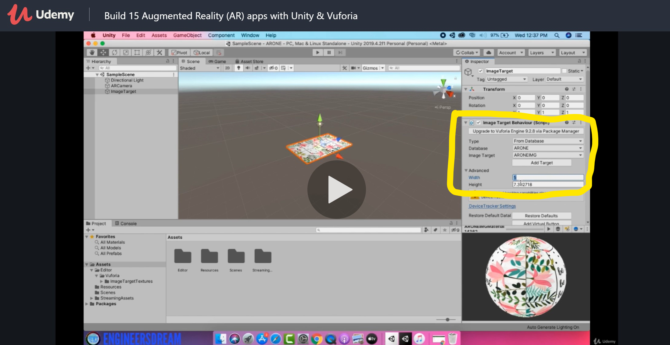

* Right-click on the hierarchy panel to add an object.
* The Image target is the picture from database. In this example, it’s the book.
  + Click on “Image Target” from “Vuforia Engine” option after right-clicking on the panel.
  + Set the data in the inspector to get the image from database.

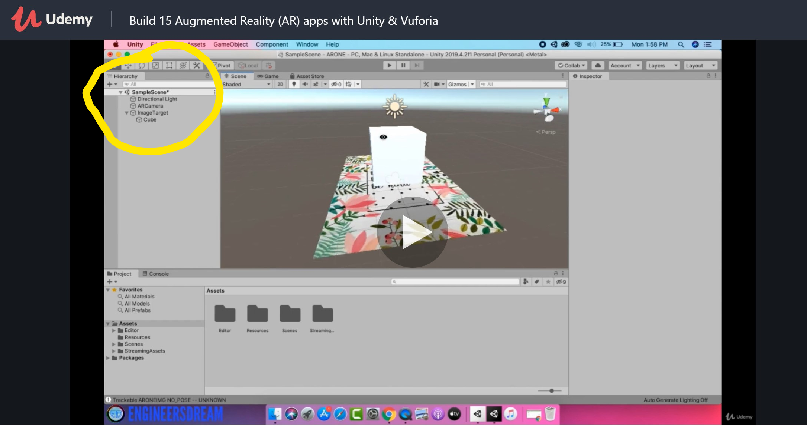

* Place the AR object anywhere you want it to be relative to the image target.
  + Make sure that the object is a child of the image target by dragging the name of the AR object onto the name of the image target on the hierarchy.
* ++ You can get free 3D objects on Asset Store under Windows tab.
* Click the play button on the top panel to test it on your camera.

Adding Shadow

* Download ARKit (an application accessible in Apple products)
* In computer graphic, shader is a type of computer program generally used for shading
  + It sets the level of light, darkness, smoothness, and color for a particular image
  + Standard Shader -> Material -> Object